**Training Centre Instructions**

IMPORTANT: IF YOU HAVE PLAYED MINECRAFT BEFORE, PLEASE ONLY USE THE KEYS BELOW TO PLAY THE GAME.

The first task to is learn how to **navigate.**

Locate these keys on the keyboard: W A S D

* To move forward, press W
* To move backwards, press S
* To move sideways to the right, press D
* To move sideways to the left, press A

Practise this by moving around the cross shape on the floor.

You can also **move your head and body, on the spot**, by using the mousepad/mouse.

* To look up, swipe upwards
* To look down, swipe down
* To swivel to the right, swipe right
* To swivel left, swipe left

Practise this now by looking around the signs on the walls.

NOW MOVE INTO THE NEXT ROOM

The next task is to learn how to **build** things.

You will see at the bottom of your screen that you have two different types of block: brown and white

To put down a block, move so that the white cross in the middle of screen is over the location of where you want the block. Right click to place the block down.

To switch between building materials, use the number keys on the keyboard (you will only need to use numbers 1 and 2).

To destroy a block if you’ve made by mistake, again move so that the white cross in the middle of screen is over the location of the block you want to destroy. Left click to destroy the block.

Practise this by building the building below, in the footprint on the floor of the room.

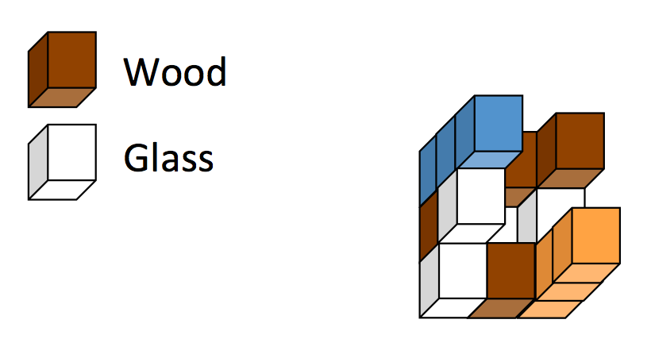

Now look around the walls of this room. There will be a colour word that you need to remember for the next stage.

NOW MOVE INTO THE NEXT ROOM. YOUR PARTNER WILL ALSO JOIN YOU.

The final task to learning how to **point**.

You can do this by looking at the thing you want to point to (e.g. using the mousepad), and jumping. You jump by pressing the space bar.

In this room, you will see three coloured blocks.

You need to point to the block picked out by the colour word in the previous room.

Your partner will tell the experimenter which coloured block they think you’re pointing to. This needs to be correct before you can move into the next room.

SUCCESS? NOW MOVE INTO THE FINAL ROOM.

In this room, you will see three coloured blocks.

In this room, your partner will point to a block.

You need to tell the experimenter which coloured block they are pointing to. This needs to be correct before you can leave the room.

SUCCESS? YOU CAN NOW PLAY THE GAME.

Walk out of the doorway, and wait by the coloured pillars for the next set of instructions.

SUMMARY OF HOW TO PLAY THE GAME

**Navigation**

* To move forward, press W
* To move backwards, press S
* To move sideways to the right, press D
* To move sideways to the left, press A

**Moving head/body**

* To look up, swipe upwards on the mousepad
* To look down, swipe down on the mousepad
* To swivel to the right, swipe right on the mousepad
* To swivel left, swipe left on the mousepad

**Building**

To place a block:

* Select the correct building material from the bottom of the screen by pressing the number keys (either 1 or 2) until the correct one is highlighted
* Move so that the white cross in the middle of screen is over the location of where you want the block.
* Right click to place the block down.
* To destroy a block if you’ve made by mistake, again move so that the white cross in the middle of screen is over the location of the block you want to destroy. Right click to destroy the block.

**Pointing**

* Look at the thing you want to point to (e.g. using the mousepad)
* Jump by pressing the space bar